Knowledge & Skills Workbook
Supply of PrEP for Clinic Support Workers

Name:
Department:
Date Commenced:
Date Completed:
Practice Supervisor:

How to use this workbook
This work book is a record of learning and continued practice for the supply of PrEP by CSW’s in SHAC. There are areas in the work book to assess your initial practice and reflect on how it went but also to allow you to continue evaluating your practice until you are able to support, teach and supervise others as a proficient role model.
Contents
1. Inclusion and Exclusion Criteria for HCA supply of PrEP
2. BHIVA/BASHH guidelines on the use of HIV pre-exposure prophylaxis (PrEP) 2018
3. PrEP issuing checklist for Non-Registered Healthcare Professionals
4. e learning for health modules
5. Competency Assessment:
6. Declaration of Competence
7. Notes review tool

1. Patient Inclusion and Exclusion Criteria to supply PrEP medication under PSD

Inclusion Criteria

- Consistent with PrEP, has attended regularly for the last year
- Aged 18 years and over and has been assessed and deemed to have capacity to consent
- Has verbally consented to receive PrEP medication from the CSW in line with this policy
- HIV negative
- Deemed eligible to receive PrEP as per BHIVA/BASHH 2018 criteria
- Willing and able to test for HIV and STIs on a 3-monthly basis as part of PrEP care through clinic setting or remotely
- Able to access clinic at least 6 monthly for monitoring, sexual health care and support

Exclusion Criteria

Aged 17 years and under
Pregnant
Breastfeeding
HIV positive
Under 35kg
Presence of an acute viral illness at start date or within the preceding month that could represent HIV seroconversion
Presence of atypical HIV test results (unchanging reactivity on two or more consecutive samples that do not fit with a pattern usually associated with confirmed positivity)
Allergy/hypersensitivity or have any contraindications to Emtricitabine, Tenofovir, Tenofovir Disoproxil, or any of the other ingredients of PrEP medicines
Acute Hepatitis C Infection
Acute or chronic Hepatitis B Infection
Known liver failure or disease
Taking medicines containing Emtricitabine or Tenofovir Disoproxil including Atripla, Emtriva and Viread, Adefovir Dipivoxil, Lamivudine and other cytidine analogues, Didanosine, Cidofovir and other medical products that compete for active tubular secretion
Taking medicines that reduce renal function including ACE inhibitors, NSAIDs, Diuretics, Angiotensin Receptor Blockers, Cyclosporine and Tacrolimus
Taking medicines which are primarily renally eliminated and have a narrow therapeutic window e.g. Methotrexate or Lithium
Known to have renal disease or an eGFR less than 60ml/minute/1.73m
Proteinuria ++ or +++ on urinalysis
Known to have bone disease or osteoporosis
Consent not provided or declines medication under PSD
Concerns about adherence to PrEP
Needing 3/12 renal monitoring
Other vulnerabilities of concern: i.e. regular Chems use, domestic abuse concerns, safeguarding

A patient who is deemed as not eligible in accordance with the exclusion criteria will not be supplied with PrEP medication and will be referred to a senior clinician for further assessment

2. BHIVA/BASHH guidelines on the use of HIV pre-exposure prophylaxis (PrEP) 2018

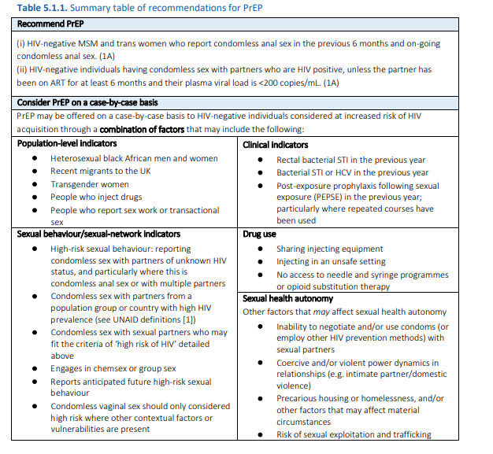

3. Emtricitabine/Tenofovir Disoproxil issuing checklist for Non-Registered Healthcare Professionals
□ Completed home test 3/12 ago
□ Has adhered to Daily or Event based dosing
□ Results from last tests checked (referred to HA if any positive results)
□ Creatinine/UPCR done today
□ Creatinine/UPCR not needed today

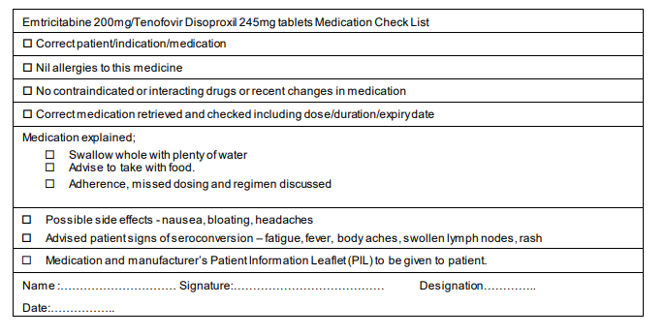

4. E learning modules undertaken:
 | Date Completed | Initial of assessor | Assessed by Certificate (C)  Observed Practice (O)  Discussion (D)  Other (please state)
The trainee has completed the following e-learning module(s):
HIV-STI 11 – HIV testing and prophylaxis
e-SRH 01_07 Confidentiality, Chaperones and Consent
HIV-STI 02_01 Interpreting Laboratory Tests
HIV-STI 02_02 Antigen and Antibody Tests
HIV-STI 02_03 Nucleic Acid Amplification Tests
HIV-STI 01_01 Sexual Behaviour and Infection Risk
HIV-STI 01_02 Sexual History
HIV-STI 01_03 Confidentiality in Sexual Health
HIV-STI 011_02 Screening Asymptomatic Patients
HIV-STI 11_01 HIV Testing
HIV-STI 11_07 HIV Pre-exposure Prophylaxis
HIV-STI 01_19 Chemsex
HIV-STI 01_20 Sexual and Reproductive Healthcare for Trans, Nonbinary and Intersex People
HIV-STI 08_12 Sex Workers

Can Demonstrate the following:
O Identifies patients who may be eligible for PrEP
O Adheres to PrEP timeline (Attached)
O Discusses PrEP options with patients
O Takes appropriate pre-PrEP bloods
O Checks results prior to dispensing
O Explains how to take PrEP
O Explains missed pill guidance
O Explains side effects
O Explains appropriate follow up
O Identifies other relevant issues, I.E. vaccination, chemsex, contraception
Can articulate the following :
O Different PrEP regimens
O PrEP follow up regimen
O Checking previous results
O What Questions to ask before dispensing
O Which tests are needed at 6 and 12 months
O When to seek advice from a senior clinican

5. Log of Non Registered Healthcare Professional Observations of
Practice
The CSW should observe a nurse or doctor competent in issuing PrEP on a minimum of 5
occasions.

Observation 1 Date: | Reflection on what was learnt:
Observation 1 Date: | Any learning points identified?
Observation 2 Date: | Reflection on what was learnt
Observation 2 Date: | Any learning points identified?
Observation 3 Date: | Reflection on what was learnt
Observation 3 Date: | Any learning points identified?
Observation 4 Date: | Reflection on what was learnt
Observation 4 Date: | Any learning points identified?
Observation 5 Date: | Reflection on what was learnt
Observation 5 Date: | Any learning points identified?

Observations discussed and approved by:
Name: ……………………………………………
Designation: …………………………………………………..
Date:………………………………………………………………
6.Log of Non Registered Healthcare Professionals supervised practice
A minimum of five observed practices (or until shows competence)
Log to be completed by the CSW and signed by observer competent in issuing PrEP

Patient No 1:
What went well?:

What can be improved upon:

Observed by: | Date:

Patient No 2:
What went well?:

What can be improved upon:

Observed by: | Date:

Patient No 3:
What went well?:

What can be improved upon:

Observed by: | Date:

Patient No 4:
What went well?:

What can be improved upon:

Observed by: | Date:

Patient No 5:
What went well?:

What can be improved upon:

Observed by: | Date:

7. Competency Assessment Checklist for Non Registered Healthcare Professionals to Supply Medication (Emtricitabine/tenofovir disoproxil) Under Patient Specific Direction for HIV Pre-Exposure Prophylaxis
Accreditation for supply of Emtricitabine/tenofovir disoproxil as HIV pre-exposure prophylaxis
In order to be certified competent to supply HIV pre-exposure prophylaxis as a Non Registered Healthcare Professional you need to have completed the following before you can supply any medication:
I verify that I have:
□ Read the Standard Operating Procedure For Non Registered Healthcare professionals to supply HIV pre-exposure prophylaxis using Emtricitabine/tenofovir disoproxil
□ Completed e-learning Complete the required observations within the competency assessment.
□ Attended CSW PrEP training session led by Clinical Nurse Specialist/Pharmacist
□ Observed 5 patient episodes undertaken by a registered healthcare professional
□ Completed a minimum of 5 patient episodes observed by a registered healthcare professional

Once the above has been completed, the workbook must be signed off by a doctor or senior nurse who, if satisfied, will certify that you are competent to supply Emtricitabine/tenofovir disoproxil as PrEP

