GENITOURINARY MEDICINE
A Guide to Specialty Training

What is GUM?
Officially called Genitourinary Medicine (GUM or GUM/HIV) but also referred to as Sexual Health and HIV Medicine. GUM is a medical specialty encompassing the management and prevention of STIs including HIV, long-term care of people living with HIV, and the promotion of sexual health and well-being. Whilst sexual health and HIV care is predominantly delivered in an outpatient setting, GUM physicians also work across inpatient HIV care, with on-call work as well as internal medicine as a Group 1 specialty. GUM incorporates clinical skills and knowledge from a variety of areas, and higher specialty trainees in GUM will gain experience in:
- STIs
- HIV
- Viral Hepatitis
- Genital Dermatology
- Adolescent Health
- LGBTQ+ Health
- Contraception and Reproductive Health
- Sexual Trauma and Assault
- Sexual Dysfunction / Psychosexual Medicine
- Public Health
- Epidemiology
- Microbiology
- Inclusion Health

HIV Medicine varies from the management of acutely unwell patients with opportunistic infections, the management of inpatients with HIV as one of many medical conditions, routine outpatient care of people living with HIV, management of viral hepatitis B/C co-infection, complex antiretroviral resistance, drug interactions, and management of chronic co-morbidities such a renal, bone, liver and cardiovascular disease.

Research is an integral part of the specialty and trainees are encouraged to participate in research. The specialty provides the opportunity to do innovative, dynamic, and impactful research including novel HIV treatments, ageing with HIV, STI treatment and prevention including HIV PrEP, epidemiology and public health research, social research and more. Trainees are supported to take out-of-programme experiences including to undertake PhDs if desired.

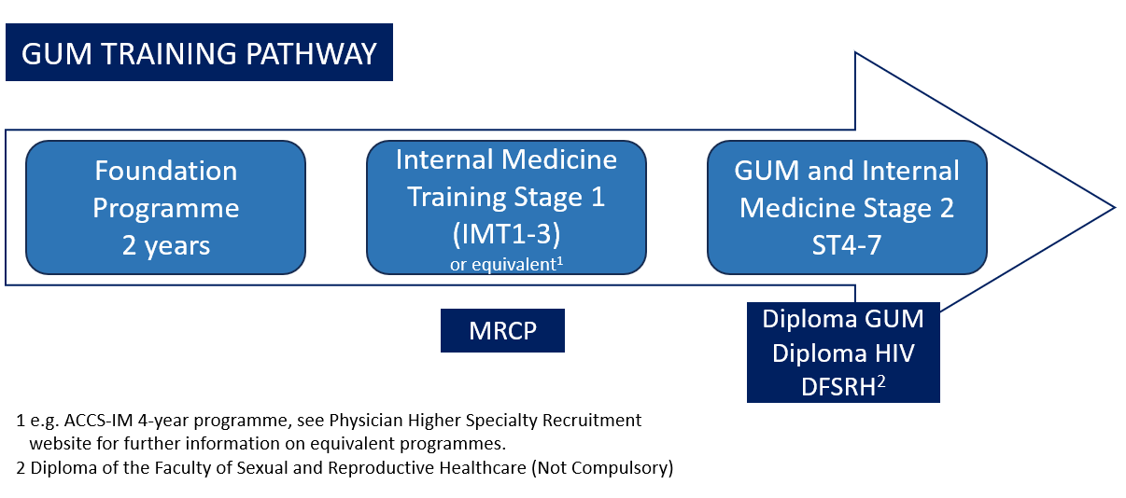

Internal Medicine
GUM is a Group 1 Internal Medicine specialty, which means trainees will obtain a dual CCT after the completion of higher specialty training. Trainees must complete 3 years of Internal Medicine Training stage 1 (IMT1-3) and then apply for and enter GUM higher specialty training at ST4. GUM and Internal Medicine Training stage 2 is 4 years (ST4-7), and trainees complete 12 months full time equivalent in internal medicine across the 4 years (usually 3 months per year whole time equivalent in internal medicine).

Curriculum
Both the GUM and Internal Medicine curriculums can be found on the JRCPTB website: www.jrcptb.org.uk
An online e-portfolio needs to be maintained throughout training with clinical workplace-based assessments (e.g. case based discussions), reflections, feedback from colleagues and patients, and annual ARCPs.

Academic Training
Academic Clinical Fellowships (ACF) are available in GUM. These generally start from ST4 and last for 3 years within your training. These are applied for and awarded through a separate process which is earlier that the standard specialty training application process. Successful candidates must still also go through the standard application and interview process. Academic trainees’ time is usually split 75% clinical and 25% research.

Less Than Full Time (LTFT) & Out of Programme (OOP)
GUM training places importance on both the training and individual needs of trainees. Trainees are supported to undertake their training LTFT if they choose. Trainees also have the opportunity to take an OOP year (or years). Examples include teaching fellowship, research fellowships or degrees, international NGO work, leadership fellowships, and subspecialty fellowships.

Exams
Diploma in Genitourinary Medicine
A best of five paper and OSCE, mandatory for all GUM trainees and required by end of ST6.
Diploma in HIV Medicine
A best of five paper and OSCE, mandatory for all GUM trainees and required by end of ST7.

Both exams are managed by the Worshipful Society of Apothecaries. See their website for the most up to date information: www.apothecaries.org

Diploma of the Faculty of Sexual and Reproductive Healthcare (DFSRH)
Focuses on contraception and is recommended but not mandatory for GUM trainees.
See the FSRH website for more details: www.fsrh.org/education-and-training/diploma

Where to find out more
A helpful list of websites and pages to follow on social media.
- Student & Trainee Association for Sexual Health and HIV (STASHH) @stashh_uk
- BASHH: www.bashh.org/bashh-groups/doctors-in-training @bashh_trainees
- JRCTB: www.jrcptb.org.uk/specialties/genitourinary-medicine
- Physician Higher Specialty Recruitment: www.phstrecruitment.org.uk/specialties/genitourinary-medicine
- www.bhiva.org

A day in the life of a GUM registrar

0900 Ward round of HIV inpatients
A mixture of patients with advanced HIV and opportunistic infections and patients with well controlled HIV and other medical issues.

1100 HIV MDT
Case discussions of patients with complex medical and social needs, drug resistance, or requiring specific antiretroviral regimens including injectable treatment.

1300 GUM complex referral clinic
A clinic for complex GUM – recurrent candida, sexual dysfunction, lichen sclerosus, herpes in pregnancy management.

Out of hours commitments, this may include:
- Evening clinic e.g., Integrated sexual health– patients presenting with STI symptoms, PrEP initiations , syphilis diagnosis and treatment, emergency contraception, adolescents attending for screening and advice.
- Non-resident evening or weekend on-calls for HIV or Infectious Diseases
- Resident evening or weekend on calls for Internal Medicine
Quotes from GUM Trainees

"What I love about GUM is being able to work in such a friendly, informal environment, with great colleagues and a strong MDT approach with various different specialties. Being able to treat a range of patients from young teenagers to older adults with a host of different health issues is a great part of the job, and rare in other specialties. Having an on-site lab and microscopy facilities which allow you to diagnose and treat patients at that very moment is extremely satisfying. Managing patients living with HIV, who can now live normal healthy lives with appropriate treatment is rewarding and you build such a strong, long term doctor-patient relationship with them - which allows us to provide them with better care in the process. The addition of GIM training is an exciting prospect which allows continuing management of various issues in medical inpatients, adds variety to the job, and is an important aspect to proving ongoing care to patients living with HIV."
David Brown, ST5, Glasgow

"No matter our cultural or geographical backgrounds, for some reason we all grow up being taught that sex is something private, secret or shameful. And yet we nearly all do it - and it's usually quite pleasurable! Sometimes, I may the first ever person that a patient has spoken to freely about their sex life, and it's really empowering and educational. And I also have a chance to identify and support the most vulnerable people out there, who are marginalised not only in society generally but often in other aspects of medicine - kids in care and care-leavers, people experiencing homelessness, prisoners, sex workers etc. You get to feel you're really making a difference."
Jo Smith, ST6, London

“As an academic trainee, there’s so many interesting areas of research in GUM/HIV covering novel HIV treatments, improving quality of life for people living with HIV, metabolic disorders in people living with HIV, HIV/STI prevention, gonorrhoea and herpes vaccines, antibiotic resistance and bacterial genomics. I’ve been able to get involved in clinical trials and epidemiological research, and have been really supported to build my own area of research expertise.”
Manik Kohli, ST6 and ACF, London

