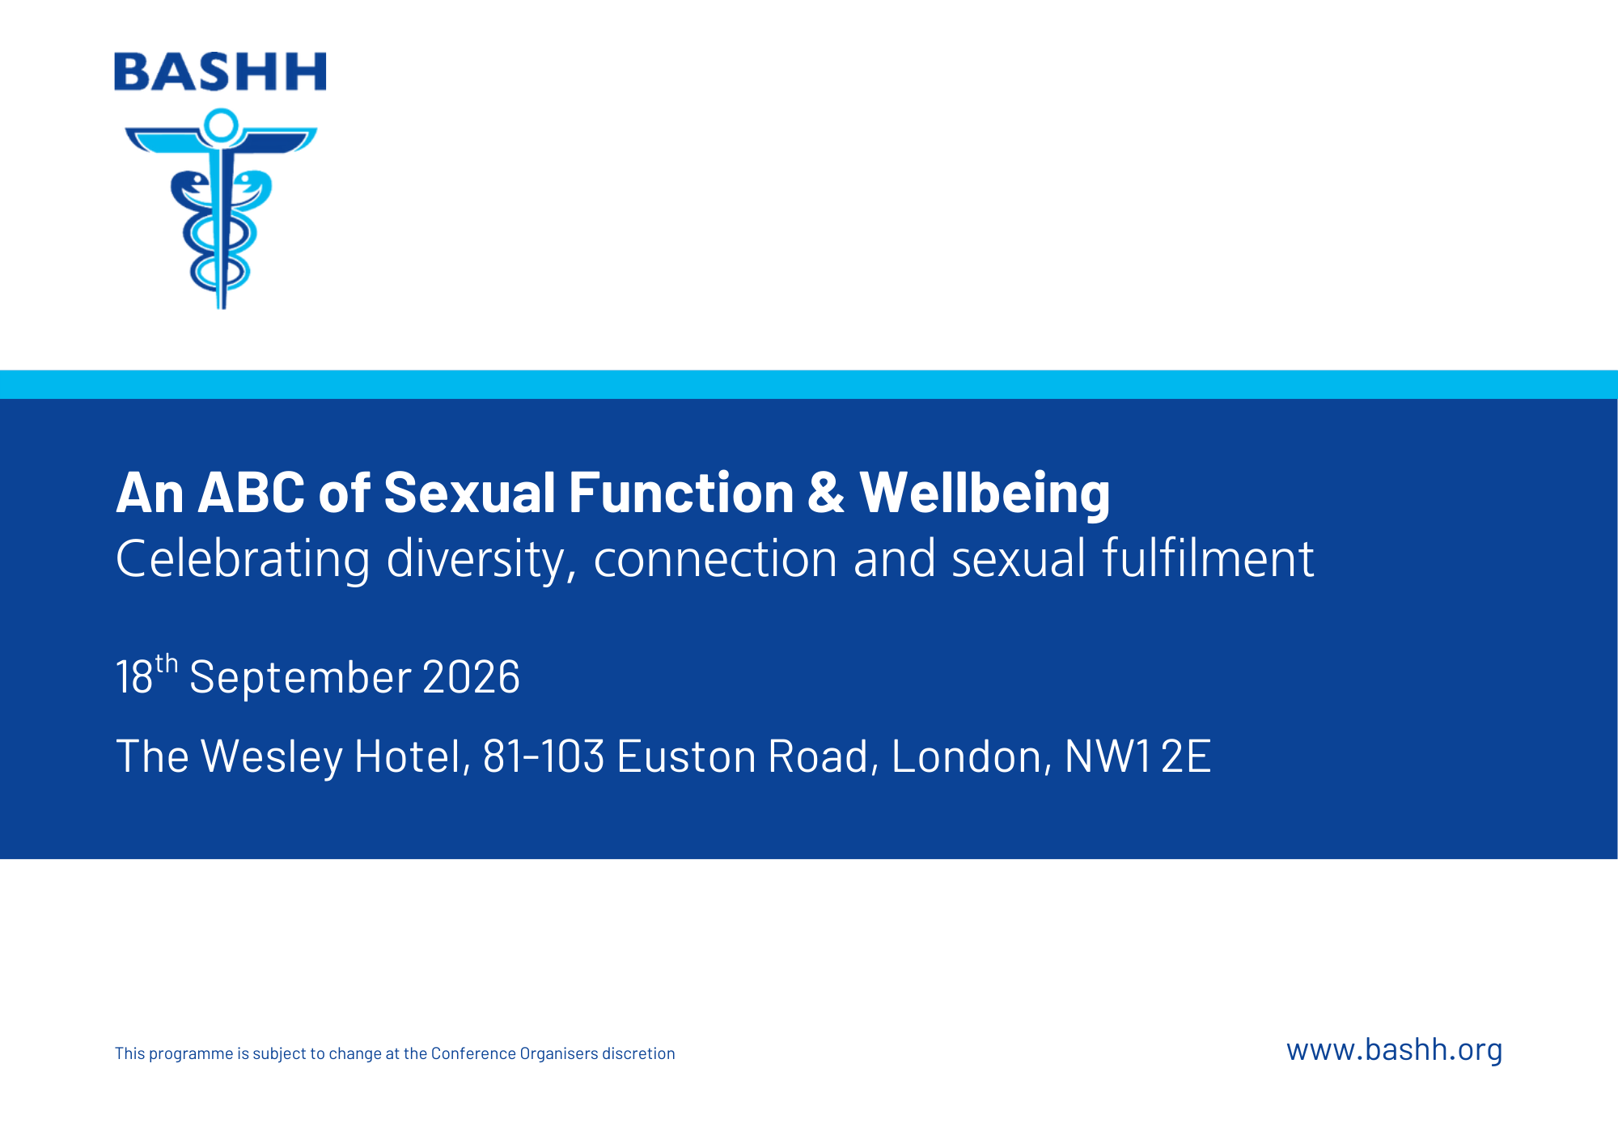

Conference Information
Join us for a bold, contemporary study day exploring inclusive approaches to sexual wellbeing - packed with practical insight, expert perspectives, and fresh ways of thinking.
This dynamic and much anticipated event invites you to rethink how we talk about, understand, and support people with sexual concerns. Designed for clinicians who want to move beyond dysfunction and deficit-based models, the day blends expert led plenaries with interactive workshops grounded in practical, real-world and sex-positive care.
Expect thought provoking conversations and evidence informed insights without pathologising difference that reflect the diversity of sexual lives—leaving you better equipped, more confident, and genuinely inspired to enhance both professional confidence and patient care.
This meeting has been supported by pharmaceutical companies by way of exhibition stand space and sponsorship which is limited to the funding of educational content of the meeting.
'An ABC of Sexual Function & Wellbeing' has been approved by the Federation of the Royal Colleges of Physicians of the United Kingdom for 6 category 1 (external) CPD credit(s). Full conditions of approval are listed in our guidelines.

Programme
Time | Session | Speaker | Room
08:30 | Registration, lunch & exhibition viewing |  | Euston Suite
09:15 | Opening and Welcome | Penny Goold | Porter Hall
09:20 | Sexual behaviour, sexual function and sexual wellbeing in Britain  What population data reveals about sexual diversity, wellbeing and contemporary sexual lives. | Kirstin Mitchell | Porter Hall
09:50 | Beyond the Missionary Position: Sexual Diversity and Wellbeing  Challenging sexual norms and celebrating diversity through a sexpositive wellbeing lens. | Julie Sale | Porter Hall
10:20 | When Sex Feels Out of Control: Supporting Change without Shame  A thoughtful exploration of sexual behaviour change focused on understanding, agency and wellbeing. | Mike Yates | Porter Hall
10:50 | Refreshment Break |  | Euston Suite
11:15 | Exploring Ejaculatory Diversity: A Sex-Positive Approach  A fresh, inclusive exploration of ejaculatory experiences that moves beyond diagnosis to context, meaning, and connection. | Stuart Gibson | Porter Hall
11:45 | Breaking the Cycle of Sexual Pain: Pathways to Comfort and Confidence  Understanding the patterns that maintain sexual pain and exploring practical ways forward. | Jess Gaddie | Porter Hall
12:15 | Pelvic Floor Function and Sexual Wellbeing: What We Assume, What Matters, and What Can Help  Reframing pelvic floor health as a foundation for pleasure, confidence, and sexual wellbeing. | Sarah Wolujewicz & Katie Webb | Porter Hall
12:45 | Lunch Break |  | Euston Suite
13:30 | Workshop 1  Delegates will be advised of their pre-allocated workshop ahead of the event. | See Workshop Section | See Workshop Section
14:20 | Workshop 2  Delegates will be advised of their pre-allocated workshop ahead of the event. | See Workshop Section | See Workshop Section
15:10 | Refreshment Break |  | Euston Suite
15:25 | Workshop 3  Delegates will be advised of their pre-allocated workshop ahead of the event. | See Workshop Section | See Workshop Section
16:15 | Where Next? Training Pathways in Sexual Function and Wellbeing  A clear guide to learning opportunities, training routes and professional development in sexual wellbeing | Zoch Nwaosu & Penny Goold | Porter Hall
16:45 | Conference close

Workshops
Upon registration, please indicate your preferred 3 workshops out of the 4 workshops that are being offered. Please note that your preferred workshops are not guaranteed. Delegates will be advised of their allocation ahead of the event.
Workshop Title | Presenter | Room
Rethinking Sexual Desire: What It Is and Why It Matters  Normalising variation in desire and arousal while supporting individuals and couples without blame. | Karen Gurney & Jane Ashby
Pleasure Over Performance: Rethinking Erectile Dysfunction  Moving beyond performance pressure to confidence, connection, and shared pleasure. | Karl Hollows
Beyond Symptoms  How psychosexual therapists formulate, assess and treat sexual difficulties using a biopsychosocial framework | Hu Clarke & Agnes Mosobela
Getting It On While Getting On  Exploring desire, pleasure, and intimacy in later life with curiosity and confidence. | Ali Mears & Suzanne Noble

Speakers
Jane Ashby | Jane Ashby is a Consultant in Sexual Health and HIV Medicine with over 20 years' experience caring for people with sexual wellbeing concerns. Her clinical interests include women's sexual health, particularly the assessment and management of sexual pain. She is passionate about providing holistic, person-centred care that addresses the physical, psychological, and relational aspects of sexual wellbeing.
Hu Clarke | Hu is an accredited counsellor and psychotherapist with over 28 years’ experience supporting people, groups and organisations through life’s challenges. He undertook a COSRT accredited level 7 diploma in Psychosexual and Relationship Therapy in 2017. He works both for the NHS and has his own Private practice and has just started a PhD at Greenwich University.  He also brings 42 years of Youth & Community work and 34 years of working within the Sexual Health field and offers clinical supervision to therapist, MDT's and counselling projects.
Jess Gaddie | Jess is a Consultant in Sexual Health and HIV at Barts. She also has a role as a Psychosexual Specialty Dr at GSTT. She has Membership with the Institute of Psychosexual Medicine and has completed the Menopause Care Professional Certificate. She has carried out mixed-methods research in vaginismus, and has created a website for patients and clinicians managing sexual pain which is used internationally.
Penny Goold | Penny Goold has been a Consultant in Sexual health and HIV since 2005 at Umbrella sexual health service in Birmingham. She is clinical lead of the Umbrella Psychosexual medicine and therapy service and works as part of the team in the Umbrella ‘Abuse survivors’ clinic(ASC)’. She is a member and seminar leader for the Institute of Psychosexual medicine and is an associate member of the College of sex and relationship therapists.
Karen Gurney | Dr Karen Gurney (she/her) is a Consultant Clinical Psychologist and European Society of Sexual Medicine accredited Psychosexologist. She leads wellbeing services at 56 Dean Street with a focus on gender and sexual wellbeing. She is also director of The Havelock Clinic, an independent MDT sexual problems service based in London. Dr Gurney has given two TED talks on sexual wellbeing, and has written two books, ‘Mind The Gap: the truth about desire and how to futureproof your sex life’ published in 2020 and 'How not to let having kids ruin your sex life' published in 2024.
Karl Hollows | Karl is an SAS doctor and Clinical Lead of the North Staffordshire sexual health service. He also holds a consultant contract leading the Psychosexual Medicine and Therapy service based in Crewe which covers Cheshire. He is a senior COSRT accredited psychosexual therapist and registered supervisor. He passed the FECSM (Fellow of the European Committee of Sexual Medicine) examination in 2016 and became as EFS & ESSM Certified Psycho-Sexologist (ECPS) in 2020, becoming the first person in the UK to achieve both qualifications. He has woven education throughout his career with regard sexual health and sexual problems and has spoken both locally and nationally. He holds an honorary contract with one UK University and has taught on psychosexual therapy postgraduate courses for over a decade.
Ali Mears | Dr Ali Mears has been working as a Consultant in Sexual health in the Jefferiss Wing, St Mary’s hospital, Imperial College Healthcare NHS Trust (ICHT) since 2007. She has a sub speciality interest in Sexual Function and is the lead clinician in the Jane Wadsworth Clinic. This is a multidisciplinary, dedicated service for adults of any gender with sexual difficulties. Anyone can be referred to this service, via their GP.  She is a member of two BASHH (British Association of Sexual Health and HIV) special interest groups; Sexual Function & Wellbeing and Sexual Violence. She has a particular interest in Domestic Abuse (DA) and Sexual violence and leads for this in her department and sits on the Trust Harmful Practices steering group.  She is a qualified Transformative Mediator and works in the ICHT Contact Mediation team. She is also a Schwartz round facilitator at ICHT.  Over many years she has worked with internationally renowned performance artists, Professor Lois Weaver and Peggy Shaw (Split Britches) on a number of collaborative projects and performances, including being a ‘Sexpert’ for ‘What Tammy needs to know about Sex and Getting Old’. She has participated in the annual Peopling the Palace festival at Queen Mary University on a few occasions, with Prof Lois Weaver. She has also collaborated with performance artist, Brian Lobel over a number of years, most recently on an ongoing project called Sex with Cancer.
Kirsten Mitchell | Kirstin Mitchell co-leads the Sexual Health and Wellbeing (SHaW) Research Group at the University of Glasgow. She is a Co‑Investigator on the Wellcome Trust–funded British National Survey of Sexual Attitudes and Lifestyles (Natsal‑4), where she leads work on the epidemiology of sexual function and wellbeing.  She has developed and validated several widely used measures of sexual function and wellbeing for clinical and public health use. She recently helped establish a consensus framework for sexual wellbeing and now co-leads a collaboration with service providers to embed sexual wellbeing within Sexual Health Services in Scotland. She co-chairs a task force monitoring progress against the Scottish National Sexual Health Strategy.
Agnes Mosobela | Agnes is a Clinical Nurse Specialist in sexual health and contraception and a practising Psychosexual Therapist. A member of the College of Sexual and Relationship Therapists (COSRT), she works with individuals and couples experiencing a wide range of sexual difficulties. Her clinical approach integrates evidence‑based sexual health practice with an informed biopsychosocial understanding of sexual functioning and relational dynamics; which includes assessment, therapeutic intervention, and sexual wellbeing education.
Zoch Nwaosu | Uzochi Nwaosu is a senior sexual health adviser and HCPC registered health psychologist working across inpatient and outpatient HIV services within a specialist sexual health setting in London. He is currently undergoing specialist training in psychosexual and relationships therapy to bring about an integrated behavioural and therapeutic approach to supporting sexual wellbeing. His clinical and research interests focus on sexual wellbeing, HIV prevention and reducing health inequalities affecting Black communities.
Suzanne Noble | Suzanne Noble is the creator and host of Sex Advice for Seniors, a fast-growing cross-platform channel and podcast dedicated to candid, humorous, and educational conversations about intimacy, pleasure, and wellbeing for adults over 50. With a highly engaged audience across TikTok, Facebook, and Substack, she is a trusted voice helping older adults feel more confident, informed, and open about sex and relationships in later life.
Julie Sale | Julie is the Founding Director and Principal of the Contemporary Institute of Clinical Sexology (CICS), a leading UK training provider of psychosexual and relationship therapy qualification pathways. She established CICS in 2016 with the aim of creating a principle-based training organisation offering high quality, contemporary psychosexual and relationship psychotherapy training courses.  Julie is a UKCP Registered and Accredited Psychotherapist by first training and a COSRT Senior Accredited Psychosexual and Relationship Therapist and Accredited Clinical Supervisor.  Julie has always made time for volunteer roles that drive inclusivity in psychotherapy. She served as COSRT Chair of Ethics from 2012-2015 was a member of the Coalition Against Conversion Therapy from 2015-2022 and now represents CICS on the Coalition for Inclusion and Anti-Oppressive Practice. Her commitment to justice in therapy is central to her leadership at CICS.
Katie Webb | "Katie Webb is a Lead Clinical Specialist Pelvic Health Physiotherapist at Imperial College Healthcare NHS Trust, working within the Jane Wadsworth national sexual function clinic and the neurological pelvic organ physiology clinic, supporting patients with complex, multidisciplinary pelvic floor needs.  Katie completed a Imperial BRC and Imperial Health Charity pre-doctoral research fellowship exploring the intersection of neurological conditions and pelvic organ dysfunction (bladder, bowel, and sexual function), incorporating semi-structured interviews to understand patients' lived experiences of neurological conditions and associated pelvic organ dysfunction.  Currently in receipt of NIHR pre-application support funding, Katie is developing a doctoral research project focused on improving the management of sexual pain following obstetric anal sphincter injury (OASI).  Katie is a member of the BASHH Sexual Function and Wellbeing Special Interest Group, London Area Representative for Pelvic, Obstetric and Gynaecology Physiotherapy, and a council member of MASIC, the Mothers with Anal Sphincter Injuries in Childbirth charity."
Sarah Wolujewicz | Sarah began her physiotherapy career in 2005 and currently leads the pelvic health physiotherapy team at Cardiff & Vale University Health Board. She previously worked in London where she led a large NHS team and worked at The Havelock Clinic, a multidisciplinary clinic for people with sex problems.  Sarah treats patients with pelvic floor dysfunction including urinary and faecal incontinence, pelvic organ prolapse and chronic pelvic pain.  She has completed a postgraduate certificate in physiotherapy in women’s health at the University of Bradford and she is currently working towards completing a MSc in Advanced Clinical Practice (Pelvic Health). She is the physiotherapist representative on the BASHH SIG in Sexual Dysfunction and she is also a full member of the Pelvic, Obstetric and Gynaecological Physiotherapy specialist interest group.  Sarah has presented at events for the public and healthcare professionals, and she has contributed to blogs and podcasts discussing the relationship between the pelvic floor muscles and ‘good’ sex.
Mike Yates | Michael is a HCPC registered Clinical Psychologist, EFS-ESSM Psychosexologist (ECPS) and COSRT registered Sex and Relationships Therapist. He is currently the Psychology Service Lead at 56 Dean Street and TransPlus, a sexual health, psychosexual and gender affirming care service. He is also one of the founding members of the Havelock Clinic, a specialist private provider of treatments for sexual difficulties, and a clinical tutor at CICS, leading provider for Psychosexual Therapy training in the UK. His clinical and research interests include the development of group programmes for psychosexual difficulties including compulsive sexual behaviours and sexualised drug use. His clinical work has focused on the adaptation of psychosexual therapies for sexuality and gender minority populations. He has recently published work focused on Compassion-focused group treatment for compulsive sexual behaviours and Chemsex in sexuality minority men.
Sponsors
 | IBSA UK & I, a global pharmaceutical company founded in Lugano in 1945, stands as a leader in the industry with a robust portfolio of 90 patent families and more in development. IBSA UK & I has 11 production sites producing 25 million hormone vials and 75 million finished product packs, spanning 10 therapeutic areas. An acquisition by current ownership in 1985, marked a pivotal shift in our vision and strategy, focusing on acquiring advanced technological resources to enhance the quality of therapeutic solutions and launching a comprehensive development program to consolidate our global expansion and asset development. With 20 subsidiaries across Europe, China, and the United States, IBSA UK & I is dedicated to improving patients' quality of life by researching and developing effective drugs and technologies that elevate existing therapeutic solutions.
 | The Urology Shop provides clinicians with an easy way to refer patients to buy high quality pelvic health products, fully VAT exempt, and with next day delivery.  We work with urologists, pelvic floor physiotherapists and specialist clinics across the UK, stocking a curated range of vacuum pumps, vaginal dilators, pelvic wands, constriction rings and more from leading medical manufacturers across the UK, US and EU.  Patients purchasing on clinical recommendation receive automatic 20% VAT exemption at checkout - no paperwork, no extra steps for your team.


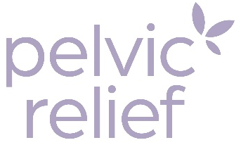 | Pelvic Relief supports genitourinary and sexual health across the life course, from vaginal microbiome screening and targeted probiotic support to silicone dilators, medical vibrators, lubricants and the Ohnut buffer ring. Clinician education and a dedicated provider portal make it straightforward to bring microbiome insight into everyday practice.

